The Dharma Workshop Testimonials

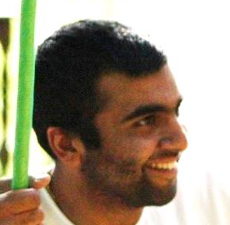
The question of finding our purpose in life is something that is core to everyone's existence. HH Sacinandana Maharaja breaks down the science of understanding oneself and teaches the audience, through tools, frameworks and interactive exercises how to maximize their potential in Krishna's service.
Shyam Gopal Dasa
Management Bsc, Cass Business School

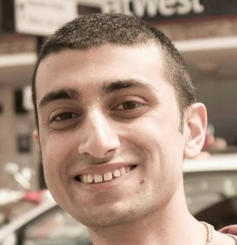
If anyone ever says Krishna Consciousness is not relevant, they haven't attended Sacinandana Swami's Dharma Worshop!
Kishan Paun
Bank of England

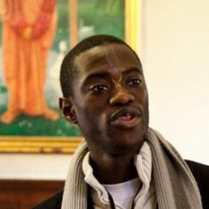
Sacinandana Swami has the unique and rare gift of being able to make timeless wisdom accessible for the modern man. The course was a revelation from start to finish. Incredible and life changing for those of us open enough to explore and apply the principles he shares.
Bhutabhavana Dasa
Management Consultant at Accenture


Sacinandana Swami provides the tools on how one can find their unique place in this world and therefore begin to live a holistic, balanced and fulfilling life. He has the unique ability to present the ancient principle of dharma in a practical way, which is not only relevant, but also extremely relatable to all.
Deenal Patel
MSc Finance, Queen Mary University of London

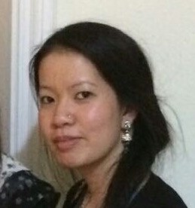
Understanding your dharma or helping others to understand theirs is an immensely deep and complex topic. I found Sacinandana Swami’s Dharma Workshop to be enlightening, refreshing, and empowering in helping me realize where my path lies and supporting others in their journey. It facilitated deep reflection and encouraged growth in ways I hadn't even considered.
Jenny Yue
Psychotherapist


Sacinandana Swami clearly put an abundance of thought and care into producing and presenting a workshop which not only inspires, but also has relevance to all in different walks of life. This workshop was filled with effective exercises, concrete examples and in-depth knowledge.
Geena Pattni
Primary Educator

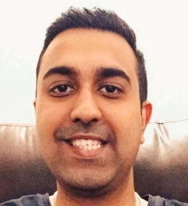
Sacinandana Swami translated a relevant yet commonly confused topic into a digestible format. Not only was I impressed with his well-planned structure of thought but I felt drawn to his truly sincere and charismatic personality. I’m forever grateful!
Ravi Pattni
Property Consultant at Foxtons

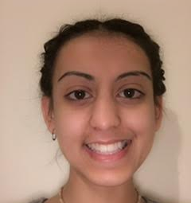
We often live an ordinary life; a life which was meant for someone else. Sacinandana Swami takes us through a process whereby we can identify what unique contribution we can offer in this world. Thus, we can begin to live a meaningful and empowered life full of strength and happiness.
Vrinda Sharma
Management Bsc, Cass Business School

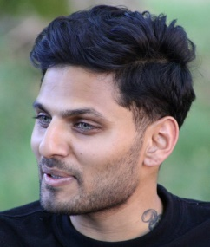
Sacinandana Swami makes this time-tested wisdom accessible, relevant and applicable for the modern individual. The exercises are engaging and his approach is authentic and genuine. Sacinandana Swami's charisma comes through and his research of the subject is thorough and impressive.
Jay Shetty
Executive Coach in Motivation and Digital Strategy

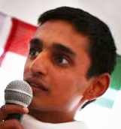
Through this module Sacinandana Swami has given us the relevant tools and practical guidance to make a unique difference in the world. With such empowering teachings, perfectly explained by Sacinandana Swami, it is much easier to maximize your potential.
Dhruva Kusa Shah
BSc Economics, University College London

Back to “The Krishna Institute: Achieving Satisfaction in Life”

